# Scenario

Create a script that builds a load balanced IIS environment using Azure Resource manager templates. Use common best practices & be ready with explanation. (Use availability set, load balancer).

# Diagram



# Resources

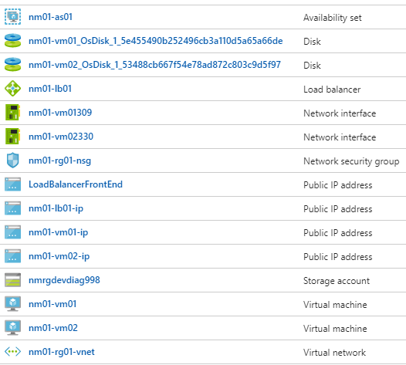

# Details

|  |  |
| --- | --- |
| **Resource** | **Subscription** |
| Name | Free Trial |
| Subscription ID | 9f847037-9073-42ac-8cdc-6cfae23a6cab |
| Tenant ID | 4daa5164-f673-4721-a1b0-28d19ca8a964 |
| **Resource** | **Resource Group** |
| Name | nm01-rg01 |
| **Resource** | **Load Balancer** |
| Name | nm01-lb01 |
| Public IP | nm01-lb01-ip |
| Load balancing rule | nm01-lb01-rule (LoadBalancerFrontEnd) |
| Health probe | nm01-lb01-probe (TCP:80) |
| Backend pool | nm01-lb01-pool (nm01-as01) |
| **Resource** | **Virtual Network** |
| Name | nm01-rg01-vnet |
| Address space | 10.0.1.0/24 |
| **Resource** | **Network Security Group (NSG)** |
| Name | nm01-rg01-nsg |
| Inbound security rule | AllowLoadBalancer |
| Network interfaces | nm01-vm01309  nm01-vm02330 |
| **Resource** | **Network Interface (NIC) 01** |
| Name | nm01-vm01309 |
| Attached to virtual machine | nm01-vm01 |
| Public IP address | nm01-vm01-ip |
| Private IP address | 10.0.1.4 |
| **Resource** | **Network Interface (NIC) 02** |
| Name | nm01-vm02330 |
| Attached to virtual machine | nm01-vm02 |
| Public IP address | nm01-vm02-ip |
| Private IP address | 10.0.1.5 |
| **Resource** | **Availability Set** |
| Name | nm01-as01 |
| Virtual machines | nm01-vm01  nm01-vm02 |
| **Resource** | **Windows Server 2016 Datacenter (VM) 01** |
| Name | nm01-vm01 |
| Size | Standard DS1 v2 (1 vcpu, 3.5 GB memory) |
| Disk type | SSD |
| Availability set | nm01-as01 |
| Virtual network | nm01-rg01-vnet |
| Network security group (firewall) | nm01-rg01-nsg |
| Network interface | nm01-vm01309 |
| **Resource** | **Windows Server 2016 Datacenter (VM) 02** |
| Name | nm01-vm02 |
| Size | Standard DS1 v2 (1 vcpu, 3.5 GB memory) |
| Disk type | SSD |
| Availability set | nm01-as01 |
| Virtual network | nm01-rg01-vnet |
| Network security group (firewall) | nm01-rg01-nsg |
| Network interface | nm01-vm02330 |